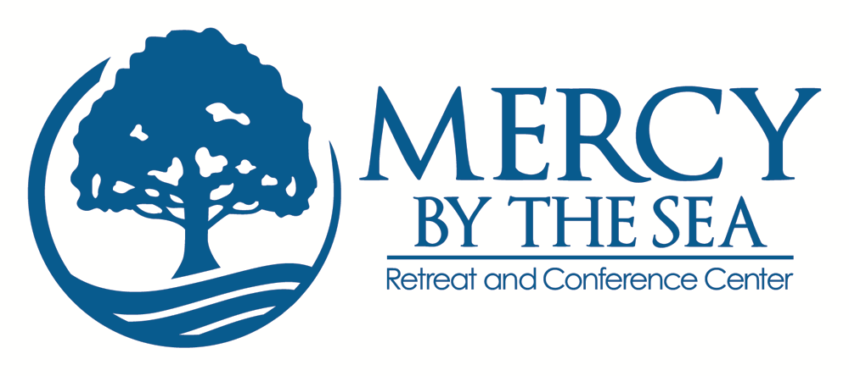
Thank you for your interest in volunteering at Mercy by the Sea. We consider our volunteers to be one of our most valued resources. What follows is our mission statement and values. If they resonate with your spirit, then this is indeed the right place for you to share your gifts and talents:
Mission Statement
Rooted in the tradition of the Sisters of Mercy, Mercy by the Sea welcomes individuals and groups of diverse faiths and backgrounds to a peaceful place of natural beauty for personal, spiritual and professional renewal and growth.

Core Values
Informed by the Spirit of the Sisters of Mercy, these values impel us to live in service to others:

- RESPECT
We reverence the dignity of each person and the sacredness of creation.
- HOSPITALITY
We provide a welcoming space and a compassionate presence.
- MERCY
We seek to reflect the unconditional love of God.
- REFLECTION
We believe a quiet environment supports creativity, transformation and a prayerful stance toward life.
- COMMUNITY
We endeavor to live in right relationship.

What in our mission and values speaks to you?_______________________________________________
_____________________________________________________________________________________
_____________________________________________________________________________________.

Name: __________________________________________________________________ Date: ________________
Address: City: ____________________________________________________________________ Zip: __________
Telephone #: ___________________________________________________________________________________
Email Address: __________________________________________________________________________________
What is your current occupation? ___________________________________________ Birthday: Month Day _____
Are you volunteering anywhere else at this time? ______________________________________________________
Name of someone to contact in case of an emergency: _________________________________________________
Phone: __________________________Work Phone: _______________________Home #: _____________________
Best way to reach this person(s):____________________________________________________________________
Do you have any medical conditions we should be aware of in case of an emergency? _________________________
_______________________________________________________________________________________________
Do you have any physical limitations/needs that need to be accommodated while volunteering? _________________
Do you have any special interests, skills or hobbies that you might like to share in some way as a volunteer with us?______________________________________________________________________________________________
_________________________________________________________________________________________________
How did you hear about our volunteering opportunities?___________________________________________________
If through a parish/congregation/organization, which one __________________________________________________
How often would you like to volunteer? Please indicate best days and times:
1 day a week ___________________________________ 2 days a week ________________________________
Please rate your computer skills:: _____________________________________________________________________
References: (please provide names and telephone numbers for two individuals we can speak with)
____________________________________________________________________________
____________________________________________________________________________
Thank you for your interest in volunteering at Mercy by the Sea.
Application can be either be emailed to amcgovern@mercyne.org or mailed to Sister Ann McGovern, RSM, Mercy by the Sea Retreat and Conference Center, 167 Neck Road, Madison, CT 06443.

